 | International Journal of Advanced Research in  Science and Technology  journal homepage: www.ijarst.com |  |  |  | ISSN 2319 – 1783 (Print)  ISSN 2320 – 1126 (Online)
Robotics Process Automation: The Virtual Worker
Mansi Varshney*¹, Divyansh², Anish Raj³ and Dr. Jyoti Verma⁴
Manav Rachna International Institute of Research and Studies
mansivarshney22@gmail.com
A R T I C L E I N F O |  |  |  | A B S T R A C T
Article history:  Received  Accepted  Available online |  |  |  | We are now using the rapidly growing artificial intelligence in our day-to-day life. Its use has greatly affected the lives of thousands of people. The increasing use of artificial intelligence means the increasing use of automation in our daily lives. We have bought automation to almost every static operation. Now, with the help of RPA, it has now become possible to bring automation to dynamic operations as well. Automation leads to higher production rates and higher productivity, better product quality and much more. RPA is used where one wants to increase the service quality or reduce the cost. RPA can be used for high priority tasks and hence no need to depend on the employees. Earlier, we were focusing on increasing the labor efficiency but now we can focus on the RPA automated automation. In this paper we have mainly focused on the RPA and how it has greatly affected our lives.  © 2014 International Journal of Advanced Research in Science and Technology (IJARST).  All rights reserved.
Keywords:
Robotics Process Automation (RPA), Artificial Intelligence (AI), Machine Learning (ML).

PAPER-QR CODE |  |  |  | Citation: Mansi Varshney et. al. Title of the article. Int. J. Adv. Res. Sci. Technol. Volume x, Issue x, 20xx, pp.xxx-xxx.

Introduction:
Imagine a robot is sitting in front of the computer and doing the same work as an employee would do and the only thing that employee need to do is to control that robot only. Isn’t it interesting? While the RPA does not involve any physical robot but there is a software robot which does the same work as the humans can do by interacting with the applications. RPA has created a better environment for the employees & also helped the customers to get their work done at a faster pace. It has made a huge impact on cutting the costs due to which the number of jobs is increasing. The best part is that those software robots can do the work more accurately and quickly [1].
In Section 2, we have discussed the related work from which we have taken reference for this paper. In Section 3, we have briefly described about the RPA. In Section 4, we have discussed the difference between RPA & traditional automation as most often there is a confusion between the two terms. In Section 5, we have discussed the difference between RPA and AI as most often people think that they are same, but it is not so. In Section 6, we have given a short brief of the advantages of the RPA and the reason behind its use. In Section 7, we have discussed the applications of the RPA i.e., where it can be used in our daily lives. In Section 8, we have discussed about the future of RPA and how it will be effective for the future use. In Section 9, we have briefly discussed the RPA tools that can be used for its applications in various areas. In Section 10, we have discussed the problem and its implementation using RPA. Section 11 and Section 12 describes the algorithm and result we get after the implementation of the algorithm, respectively. Then, finally we conclude in Section 13.
Related Work:
Divyanshu Rai, Sumbul Siddiqui, Dr. Mahesh Pawar and Dr. Sachin Goyal in their research paper “Robotic Process Automation: The Virtual Workforce” presented that the use of RPA may vary depending upon the requirement and the scope of the organization. In future, the RPA may replace the human workforce up to some considerable amount.
K P Naveen Reddy, Undavalli Harichandana, T Alekhya and Rajesh in their research paper “A Study of Robotic Process Automation Among Artificial Intelligence” presented that RPA uses software package and methodologies that are capable of taking advantage of the most recent technologies together with artificial intelligence, machine learning, voice recognition, and linguistic communication process to require automation to future level. They concluded that RPA can easily replace humans in complex processes whenever required [2].
Santiago Aguirre and Alejandro Rodriguez in their research paper “Automation of a Business Process Using Robotic Process Automation (RPA): A Case Study” concluded that RPA is more suitable for high volume standardized tasks that are rules driven, where there is no need for subjective judgement, creativity or interpretation skills. It is important to consider that RPA does not store any transactional data and does not require a database. They also presented the benefits of RPA. They mainly focused on the integration of RPA with BPMS and in the future with cognitive automation tools [3].
G. Ghosh in his research paper “Automation with RPA (Robotic Process Automation)” presented that although robots are good at extracting, processing and integrating information but they do not really understand the information. Due to this a considerable measure of research work are working in CDA (Cognitive Document Automation) [4].
Robotics Process Automation:
Fig 1_Robotics Process Automation
RPA itself consists of three words- Robotics, Process and Automation. Robot is defined as an entity which can be programmed by a computer for doing complex tasks i.e., an entity which can mimic the human activities. Process is defined as a sequence of steps, that leads to meaningful task and when the task happened automatically i.e., without human intervention, it becomes an automation.
Robotic Process Automation is a combination of hardware and software. A machine or bot that reduces human effort or can say decreases workload. It is very easy to use and control, only a simple command and they are ready to serve for any task. It can do tedious and complex tasks in a simple and easy way. Many big companies are making use of automation skills to run their companies. In the coming future, RPA can replace human load, in different sectors. In different countries, there is a huge demand for robotic equipment to help in their business and markets [5].
RPA software runs at the “presentation layer” of computer systems and appears as the applications to its users. Its software program runs on an end user’s pc, laptop, mobile phone etc. Its commands are executed by Bots under some set of business rules. It has the dynamic nature which helps the organizations that want to deploy the automation solutions in response to changing business climate.
The field of Artificial Intelligence has been taken to another level by the Robotics Process Automation. Both RPA and AI are working together to increase the efficiency.
The main purpose of the RPA is to automate the workflow, infrastructure and the processes which are dependent on employees. Its goal is to reduce the efforts of the labors who do a particular task again and again.
Difference Between RPA and Traditional Automation:

The technology difference between both is that RPA uses software bots while traditional automation makes use of APIs. RPA is more convenient in technology base and area.
Traditional Automation is software limited whereas RPA works on the UI layer. In Traditional Automation, due to the lack of software code and APIs limitation, there is restriction in application customization. These restrictions are not there in RPA.
RPA offers high level customization as compared to Traditional Automation as RPA makes use of bots that can meet the needs of each user [6].
RPA has faster turnaround time than traditional automation as it does not require complex programming and testing efforts.
Difference Between RPA and AI:
Many people often get confused between RPA and AI. They sometimes even think that both are the same, but they aren’t. There is a huge difference between the two. RPA is basically a software robot which can mimic the human activities whereas AI is the simulation of human intelligence by machines.
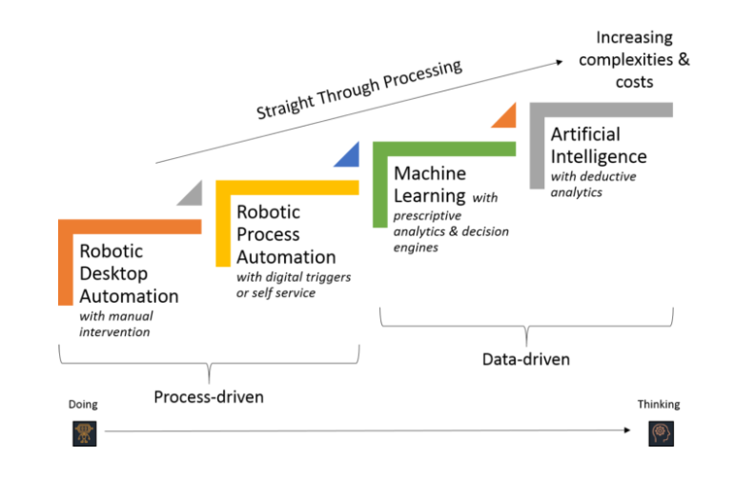
Fig 2_Difference Between RPA and AI

As shown in the above picture, RPA is associated with “doing” a particular task whereas AI is associated with “thinking”. RPA can easily do the repetitive tasks once it get instructed like copying and pasting data, scraping data from the web, logging the applications, opening emails etc. whereas AI can perform the task where some intelligence is required like processing languages, understanding documents and files, handling unstructured data, visualizing screens etc. Hence RPA is process-driven i.e it automates the tasks repetitively and AI aims at producing good quality data. Buts its not that one is better than other, it’s all about the application or a project. It is possible that one application requires RPA and other application requires AI. Therefore, both are good at their place and if both are used collectively, then the output produced will certainly of good and advanced quality.
Advantages of RPA:
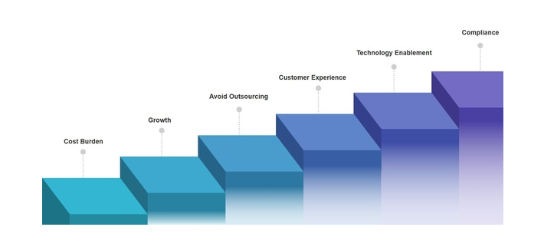
Fig 3_Advantages of RPA

1). Accuracy and Quality: The accuracy and quality of a work done by RPA is much greater than the work done manually. RPA provides 100% accuracy while if the same work is done by a human then there may be the chance of human error. As the robots work tirelessly, they can do the same work with the same quality and therefore, maintaining the consistency.
2). Increases Employee Productivity: Earlier, all the work was done manually due to which the employee got tired very soon which results in the decreased efficiency of an employee. Decreased efficiency of an employee means the decreased productivity. But now repetitive tasks can be done with the help of RPA and hence it frees the employees from that boring task. So, the employees can now focus on other important works easily like they can give more time to interact with their customers [7].
3). Increased Customer Efficiency: When the employees give more time to their customers, listen to their problems patiently, interact with them frequently and helps them by solving their problems in less time, then it is obvious that the customers will be highly satisfied with that company and their employees. All this leads to increased customer efficiency.
4). Faster: As bots are handling the execution, therefore a particular work can be done in a relatively lesser time.
5). Reduces Output Variability: There is no chance of output variability as the work is done by the bots which almost duplicates the given task. Since bots are good at duplicacy, therefore if the same task is performed by the bot, then it will be indistinguishable.
6). Cost Effective: RPA cuts operational costs as robots can be operated 24/7 without any leave or vacation while the humans can’t do work 24/7 or without any leave [8].
7). Better Record Keeping: Bots always make a file or document of whatever it has done. So, it keeps record of everything performed by it. Records are needed whenever there is an unexpected shutdown.
8). Impact is delivered quickly: The organizations need not to wait for years to get the benefit of using RPA. They usually get their benefit in just a week. Hence, its impact is delivered quickly to the organizations.
9). Reduces Paper Waste: As everything is becoming digitalized, the bots also perform its every task in the digital form. Digitalization helps in performing the task easily and keeping the records safely. Hence, there is no longer requirement of performing all the tasks on paper which results in saving of paper.
10). Higher Speed and throughput: As the tasks are performed and executed by a machine or robots, the speed is much high, and the task is performed in the real-time. Example- credit checks etc.

Applications of RPA:
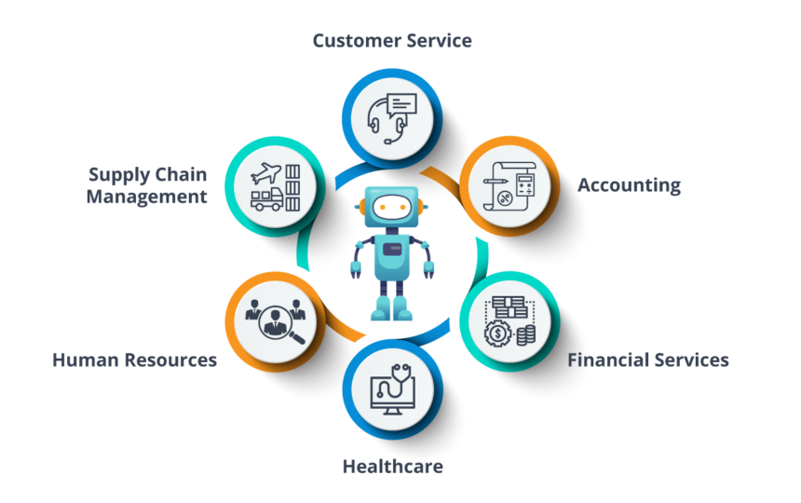
Fig 4_Applications of RPA

1). Healthcare: When an individual visits to hospital, then for the registration, an employee manually enters all the information of that individual. This is task is very time-consuming as well as boring. By making use of bots, patient’s registration task becomes very easy.
2). HR: When a new employee joins the organization, then an employee from that organization enters all the formalities manually. Since this is a repetitive task, this job can be done with the help of bots in an efficient way and in less time.
3). Manufacturing and Retail: When an individual buys several products, then making the bill manually and doing all the calculations is such a tedious task. Instead of this, making use of bots will be a good alternative.
4). Travel and Logistic: Booking the tickets, filling the details of the thousands of people manually is obviously not a good option as it is going to be a tedious job. Here, RPA can be used to save the human efforts and time.
5). Banking and Financial Services: In this area, RPA can be used for the card activation, claiming the frauds, accounting etc. This will really make the job easier and time saving.
Future of RPA:
The impact of RPA will get spread within the organizations as it is really helping the organizations in many ways. In the coming years, the organizations will find more different ways to make use of RPA and in different processes. There is a lot to do research in this area and hence organizations will surely take it to the next level.
Organizations have found that using automation tool as stand-alone system will surely be not a good idea unless it is integrated with some other tool to make the best use of the tools. Although RPA can work well on its own but integrating it with some other tools will surely produce a good result [9].
The next step for the RPA market is the Artificial Intelligence (AI) and self-learning capabilities. In the coming future, it will start to integrate the aspects of AI and may even left AI behind itself i.e., RPA will be a futuristic technology. Analyst have said that the future of the RPA will be bright especially in the areas where low code meets AI. According to an estimation made by an analyst, global software revenue of RPA may climb up to $1.89 billion in 2021, with an annual growth of 19.5% from 2020.
RPA Tools:
RPA tools are the software that helps to configure task so that they can get automated. Now, it all depends upon the capabilities of the tools that helps the industry to choose a right tool for themselves. Based on the functionality the tools deliver, RPA bots are divided into 3 sections:
- Cognitive Capabilities
- Programming Options
- Usage
There are various RPA tools to make a task automated:
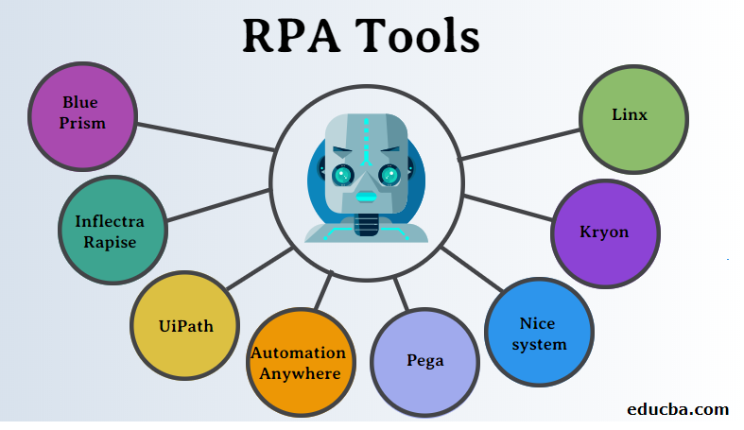
Fig 5_RPA Tools

1). UI Path: It provides free community edition which is very helpful for those who don’t know about programming. It supports web and desktop applications. It provides scrapping solutions and multiple hosting options.
2). Blue Prism: It is one of the famous RPA tools that helps the organizations by providing them virtual workforce. It provides drag and drop option that makes the automation process easy. Mostly, all the major cloud platforms are supported by it. It can be used on any platform as it is platform independent [10].
3). Pega: It helps in speeding up a particular manual task by using automation process. It provides automation using UI of existing applications and provides cloud-based solutions which makes it different from other tools.
4). OpenConnect: It is an RPA tool which automatically discovers, automate, and increases workforce productivity. It also improves service processes on its own. It provides highly secured and encrypted data and advanced connectivity capabilities.
5). Redwood: It automates simple to complex tasks very easily. Any process can be robotize easily using this software as it provides the unique network services. It allows to run, clone, and edit bots in an easy way which is one of the most important features a tool should have.
Problem Statement and its Implementation:
Let us consider a situation from our everyday life. We usually waste a lot of time in searching a particular item from e-commerce site like Flipkart, Amazon etc. Especially, it is a very tedious task for the aged people. To solve this problem, we can use RPA tools. It can be used to get the list of all the related items and its description alongside so that it will become easy to look for a product. To solve this problem, we have used UiPath Studio. We have used Gmail to receive the name of the object to be searched and send back the excel file which will contain the product details to that mail only.
Algorithm:
1. Insert the Sequence Activity
- produce a variable mail that contains your mail id.
- produce a variable pass that contains your countersign.
2. Insert Get IMAP Mail Messages Activity
- modification Port range to 993.
- modification Server to ―imap.gmail.com‖.
- Insert mail in Email.
- Insert pass in countersign.
3. Insert for every Activity.
4. Insert Open Browser Activity
- Change URL to "https://www.flipkart.com/search?q=" + mail.Subject + "&as=on&as show=on&otracker=start&aspos=1_q_iph"
5. Do information Scrapping.
6. Insert Write CSV Activity.
- modification File Path to current directory.
- modification DataTable to ExtractDataTable.
7. Insert Send SMTP Mail Message Activity
- modification Port to 465
- modification Server to ―smtp.gmail.com‖.
- Insert mail in Email.
- Insert pass in countersign
- Insert mail in To.
- Insert mail in From.
- Insert this directory location in attach files.
8. Click on Run.
Result:
If we ship a mail having ― Samsung Mobiles ― as its subject, we will be able to obtain an excel report having the information of all the Nokia mobiles which can be gift on Flipkart. Data Scrapping can be carried out on the net web page furnished in the URL of Open Browser Activity. After Opening the website --Samsung Mobile ―can be searched and the related information (Item name, Price, ROM, Camera), which had been selected can be returned.
This information then be copied in an Excel sheet and the excel report can be mailed to the respective mail identification using Send SMTP Mail Message Activity. Similarly, we can carry out the identical undertaking on various websites. We can also carry out this on distinctive websites to examine their effects and discover the optimum product primarily of the required specifications that we want. This is only a simple instance on how we will use Robotic Process Automation in our day by day lives. It has various packages in lots of big industries.

The following excel sheet shows the result of the above problem statement.

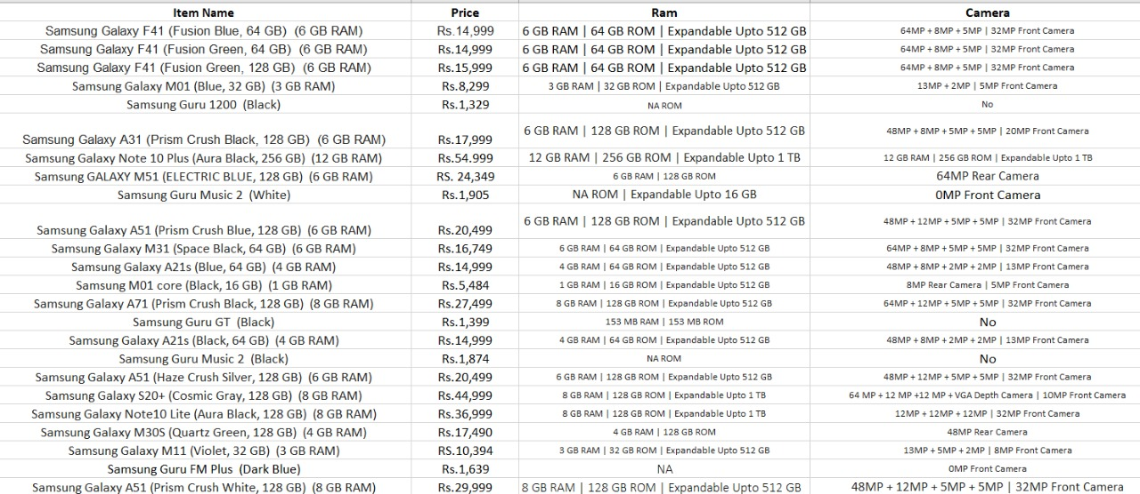

Table 1 . Result of the Problem Statement

Conclusion:

Robotics Process Automation provides advanced software system robots that can be replaced with humans for the complicated tasks. Hence no need to rely on humans for the complicated work. Humans can make mistakes, but a bot can’t, which automatically increases the efficiency of any task. It just follows the instructions given to it. RPA makes use of software methodologies that are capable enough for making the use of AI, ML, and other technologies. The organizations are making most use of the RPA and it has been proved beneficial for them in every aspect. Now, the number of organizations making use of RPA is also increasing as it is really helping them and making their work easy and fast. RPA automate processes enabling business transaction and hence greatly affecting the digital markets. It will definitely grow in future and will combine with other technologies to make the most use of itself. In this paper, we have just given a small example of how to use RPA in our everyday lives. On the larger scale, we can use it for other big purposes so as to free the employees from doing the repetitive tasks.
References:
- Rai, D., Siddiqui, S., Pawar, M. and Goyal, S., 2019. Robotic Process Automation: The Virtual Workforce. International Journal on Future Revolution in Computer Science & Communication Engineering, 5(2), pp.28-32.

- Reddy, K.N., Undavalli Harichandana, T.A. and Rajesh, S.M., 2019. A Study of Robotic Process Automation Among Artificial Intelligence. International Journal of Scientific and Research Publications (IJSRP), 9(2).

- Aguirre, S. and Rodriguez, A., 2017, September. Automation of a business process using robotic process automation (RPA): A case study. In Workshop on engineering applications (pp. 65-71). Springer, Cham.

- Ghosh, G., 2018. Automation with RPA (Robotic Process Automation). International Journal of Computer Sciences and Engineering, 6(8), pp.475-77.

- Grung-Olsen, H., 2017. A strategic look at robotic process automation. BP Trends.

- Jovanović, S.Z., Đurić, J.S. and Šibalija, T.V., 2018. Robotic process automation: overview and opportunities. Int. J. Adv. Qual, 46(3-4), pp.34-39.

- Doguc, O., 2020. Robot process automation (RPA) and its future. In Handbook of Research on Strategic Fit and Design in Business Ecosystems (pp. 469-492). IGI Global.

- Devarajan, Y., 2018. A study of robotic process automation use cases today for tomorrow’s business. International Journal of Computer Techniques, 5(6),
pp.12-18.

- Madakam, S., Holmukhe, R.M. and Jaiswal, D.K., 2019. The future digital work force: robotic process automation (RPA). JISTEM-Journal of Information Systems and Technology Management, 16.

- Pranav Desai. Introduction to RPA. International Research Journal of Engineering and Technology (IRJET).

